Template SOP 140518

Table of Contents

1 Overview 2

2 Scope 2

2.1 Materials and Tools 2

3 Templates 3

3.1 Process Overview 3

4 Template SOP 4

4.1 Set Null template 4

4.2 Scan test object 6

4.3 Edit EXIF data 6

4.4 Upload images 8

4.5 Download model files 8

4.6 Extract data 9

4.7 Preview data 10

4.8 Measure and Calculate 11

4.9 Scale data 12

4.10 Use 3dpToTemplate to remove data 13

4.11 Upload template to server 13

4.12 Select new template 14

4.13 Scan test object 15

4.14 Validate scale 16

5 Appendix 17

5.1 Null template 17

5.2 Deficiencies 18

# Overview

This SOP is for creating custom templates for SugarCube shooting strings. Accurate scaling requires accurate templates. Any change to a shooting string will require a new template for accurate scaling.

# Scope

This document lists Process steps for creating custom templates.

## Materials and Tools

To exercise this SOP you will need both of the following applications;

|  |  |
| --- | --- |
| ***Article*** | ***Role*** |
| SugarCube Manager (SoundFit) | Set template for modeling |
| SugarCube Tester (SoundFit) | Run scan scans step by step |
| Netfabb Studio (free) | App for measuring 3D model features |
| template_140508-1143_UNSCALED.3dp | Template without positioning info forces the modeling to calculate position |

# Templates

Templates are used for the initial starting point for modeling. Templates reduce modeling time and afford scaling to the model. The thing about templates is that they require accuracy and they don’t. Templates need to be very precise to ensure accurate scaling. Slight deviations can create large errors, however small errors in position still achieve good models off in scale.

**Rule of Thumbs:**

* Each and every shooting string will require a unique template
* A good modeling can be achieved with small errors in position, however accurate scaling requires accurate positioning.

## Process Overview

The process is simple and can be automated going forward.

1. Select Null template with SugarCube Manager (automated later)
2. Scan test object of known dimensions with SugarCube Tester
3. Set image EXIF focal length to 38 (automated later)
4. Upload image-set to server (automated later)
5. Download model files
6. Extract files (automate later)
7. Use 3dp viewer to view profiles
8. Measure object and Calculate scale
9. Use 3dp viewer to scale positions
10. Use 3dpToTemplate app to remove URL’s (automate later)
11. Upload templates to Server (automate later)
12. Select new template with SugarCube Manager (simplify later)
13. Scan object
14. Verify precision

While this may seem lengthy it is shorter than using the RECAP API which added more time and labor to the process.

# Template SOP

DRAFT Standard Operating Procedure (SOP) for creating templates.

## Set Null template

Run the SugarCube Manager

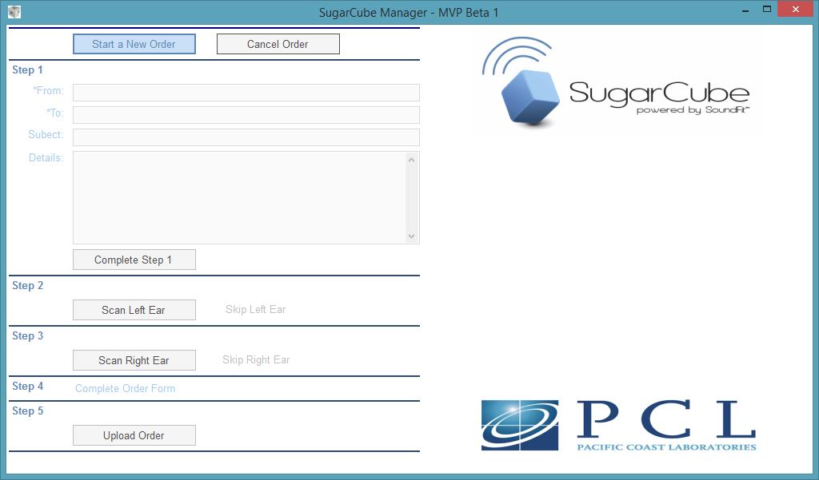

Click CTRL and ALT and A to access the configuration manager

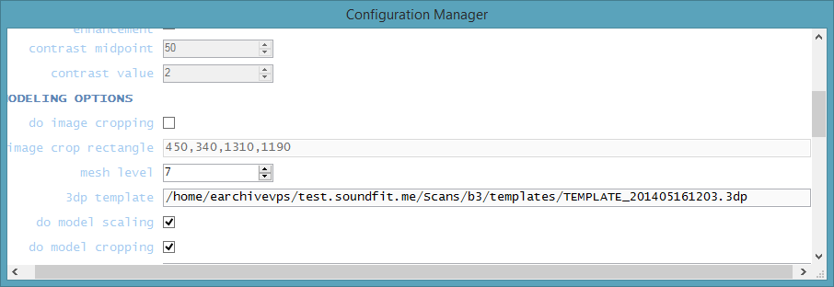

Change template to “template_140508-1143_UNSCALED.3dp” as shown below

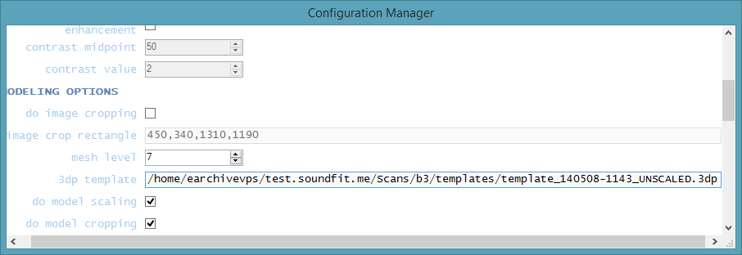

Notice: the appendix shows an example of a Null 3dp file.

Scroll to bottom and click OK to save change

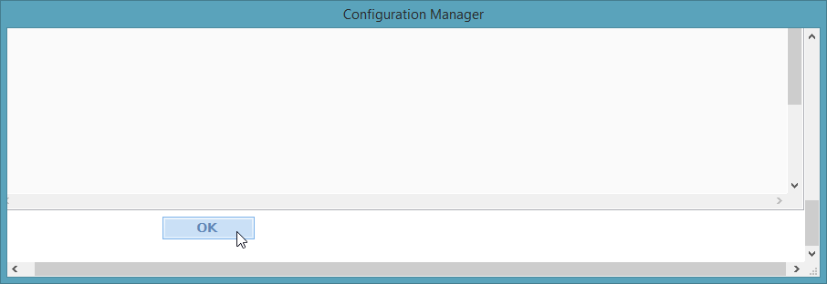

Exit SugarCube Manager

## Scan test object

Ensure an object with known dimensions is inside the SugarCube.

Run SugarCube Tester. Then click ***Run Shoot String***.

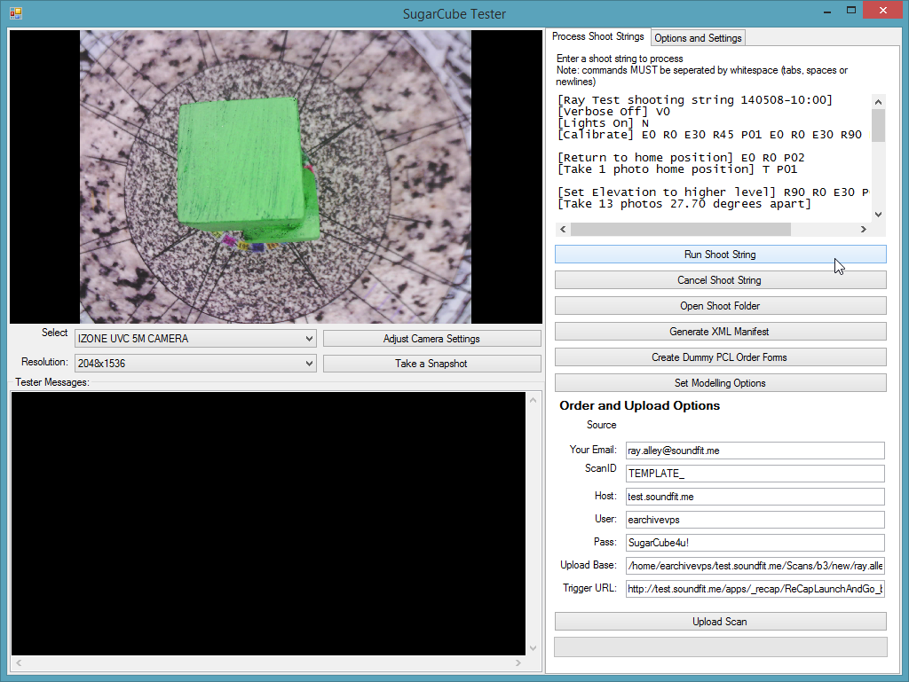

## Edit EXIF data

Select ***Open Shoot Folder***.

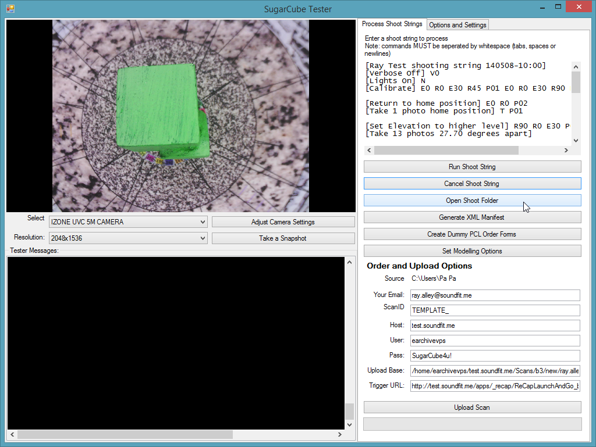

Select all images then right click on ***Properties***.

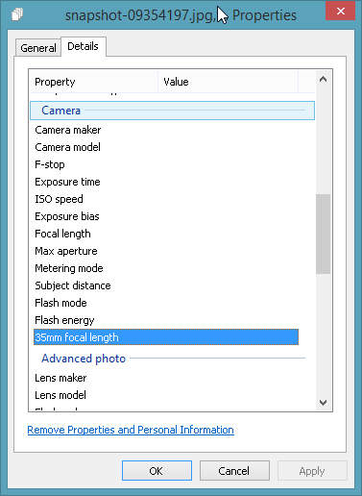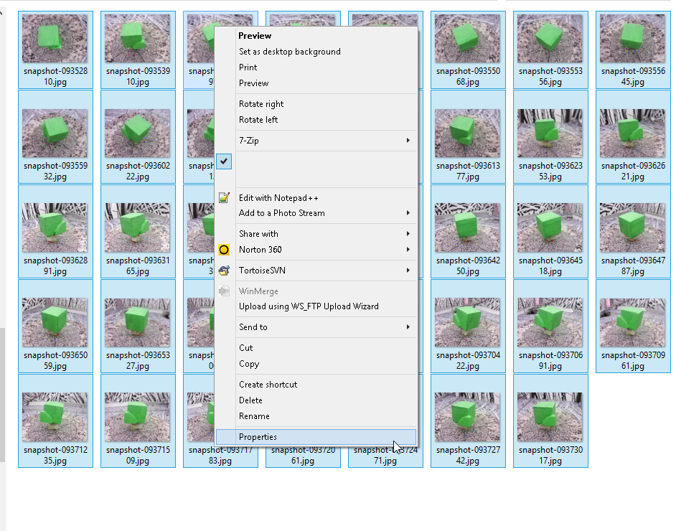

Scroll down to ***35mm focal length***. Enter the value 38. Then click the Enter button. The Apply button becomes active. Click the Apply button. Then click the OK button.

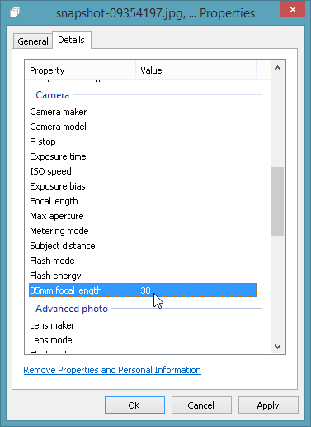 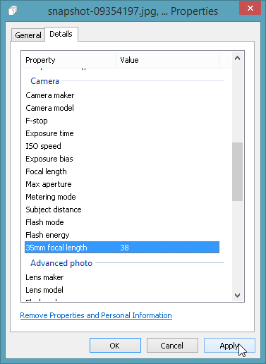 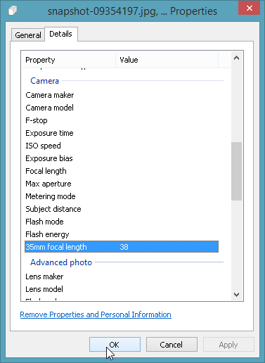

## Upload images

Click ***Upload Scan***.

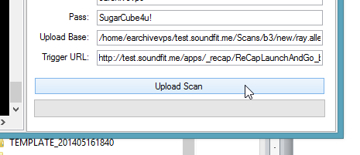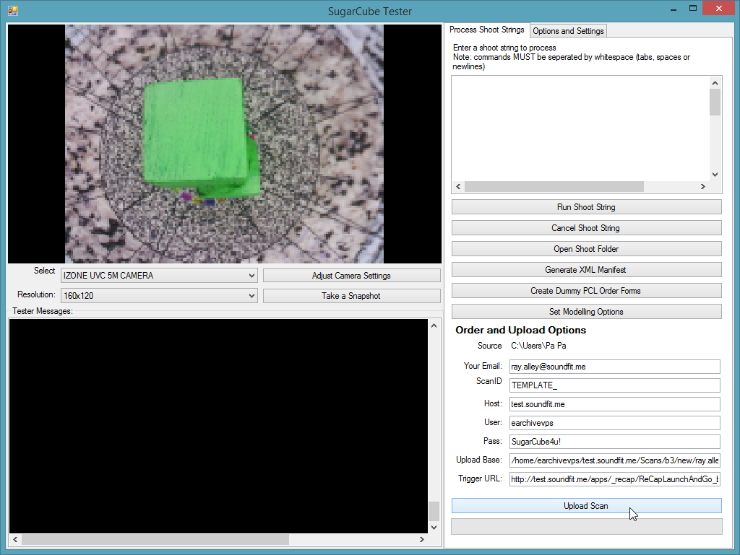

## Download model files

Data is retrieved via email links to various data components such as STL and 3DP files along with a 3D model viewer.

Review 3D model link it must be good to be a template!

Then click on the 3DP link to download file.

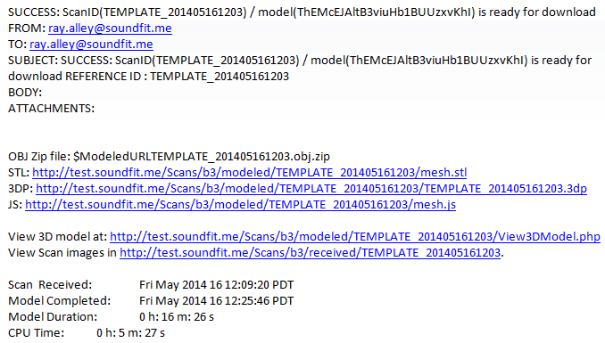

## Extract data

3dp files are saved in a compressed format. An extracting (or uncompressing) application is needed to extract object file.

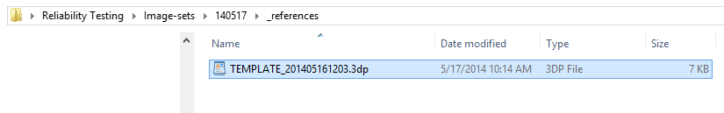

First rename the file changing the extension from 3dp to rcp. The rcp format goes back to Autodesk reference.

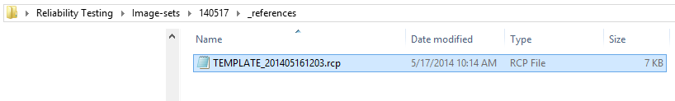

Run file extracting program. The extracted file has no extension in example below.

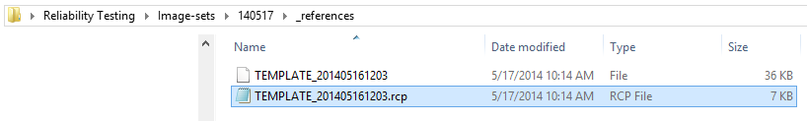

Select and COPY template. Place a copy in the “3dpToTemplate” folder.

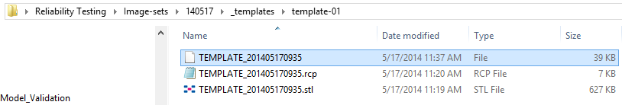

Details of the 3dpTotemplate application were previously discussed in earlier documents.

## Preview data

Use the 3dp viewer to ensure data looks good. Lines should be flat and circle should be round.

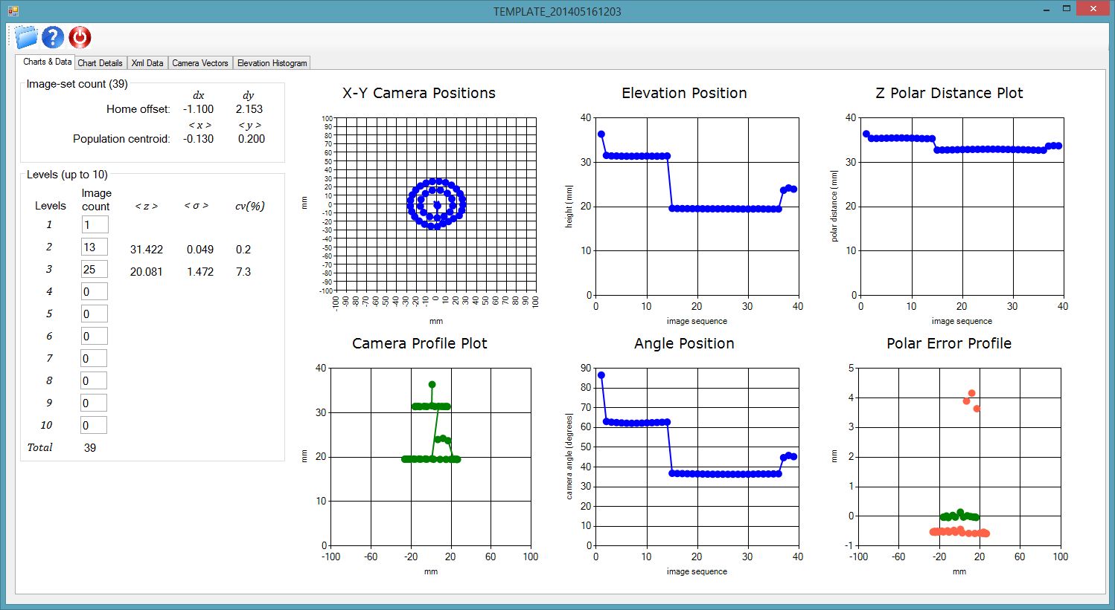

It’s okay to scale up to observe details. Errors occur if the scale increases the object beyond 100*mm* from the origin.

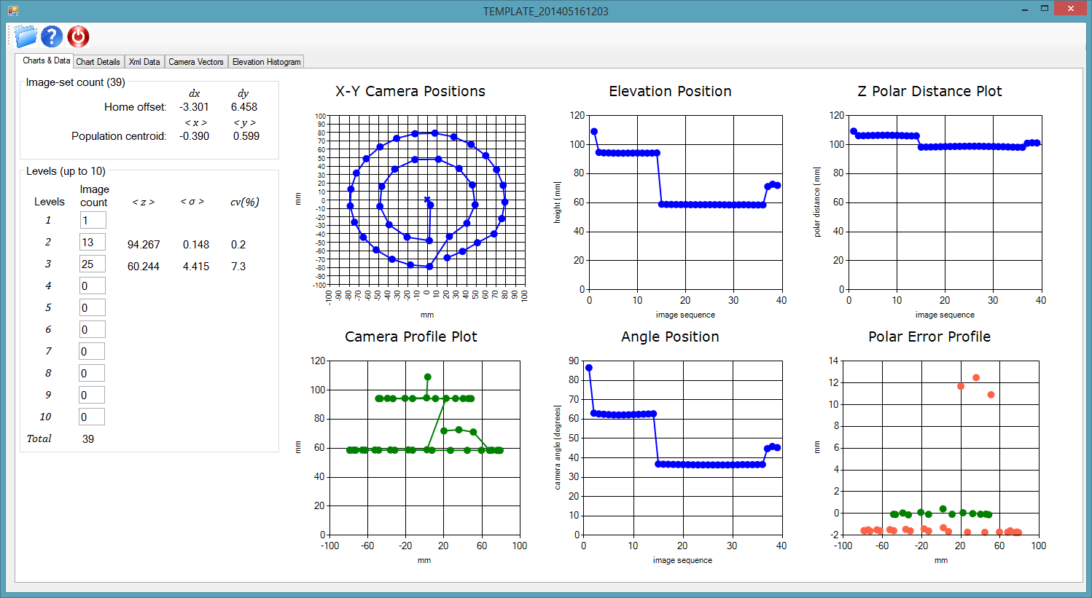

## Measure and Calculate

Open the STL file and measure the dimensions of the object.

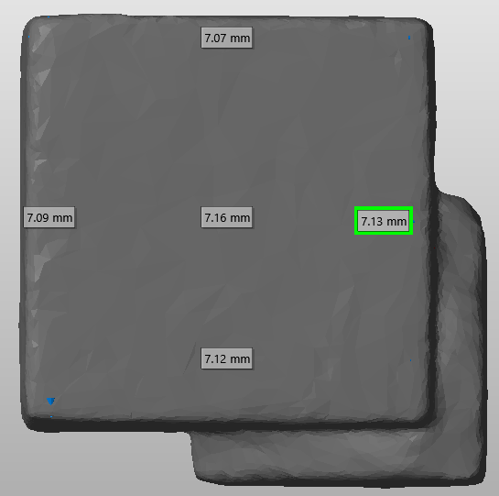

Enter the six dimensions into the worksheet to calculate the average length. Divide this by the known length to obtain the scale. High accuracy requires accurate scaling. The scaling factor should be taken to 4 places to ensure accuracy.



## Scale data

Use the 3dp viewer to scale and validate scale change. Open 3dp viewer and load template to modify. Go to ***Charts & Data*** tab and view 1st chart shown.

Enter 3.0597 from the calculation above into the scale box and click the Re Scale Positions button. This creates a new dialog checking to make sure you want to proceed with this operation.

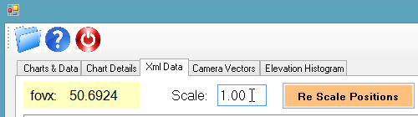 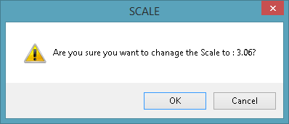

When completed the scale has changed. The app needs updating to display 4 digits.

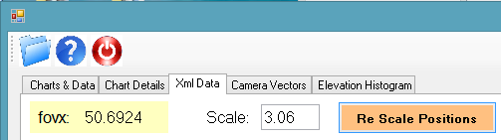

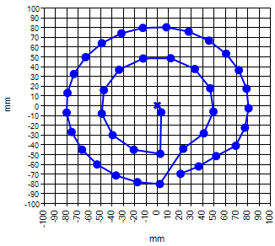

You can review charts to validate change. If the change was greater than 10% it should be noticeable as illustrated in this example between before shown above and after shown left.

## Use 3dpToTemplate to remove data

Autodesk gave us an application for remove unwanted data. I’m sure this is something we can take care off in the next few versions.

From the Command Prompt enter:

“**3dpToTemplate** TEMPLATE_201405170935 TEMPLATE_201405170935.3dp”

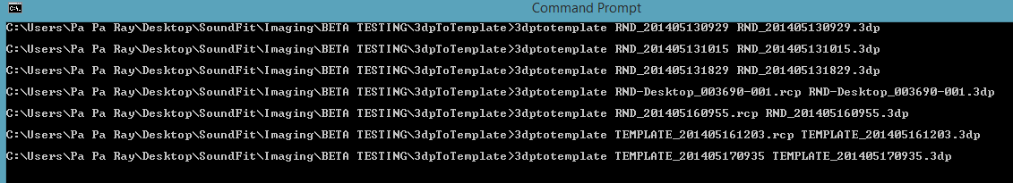

Copy newly created template named “TEMPLATE_201405170935.3dp”. Place a copy back in your original template folder.

## Upload template to server

I used WinSCP to upload template to server. This function can be incorporated in the ***Tester***.

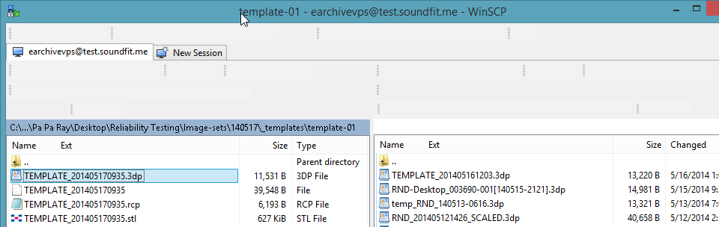

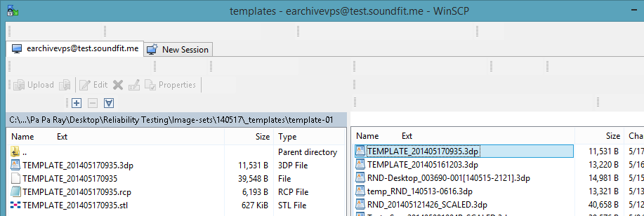

## Select new template

Run the SugarCube Manager.



Click CTRL & ALT and A to access configuration manager. Change template to “TEMPLATE_201405170935.3dp”, shown. Click OK to save change.



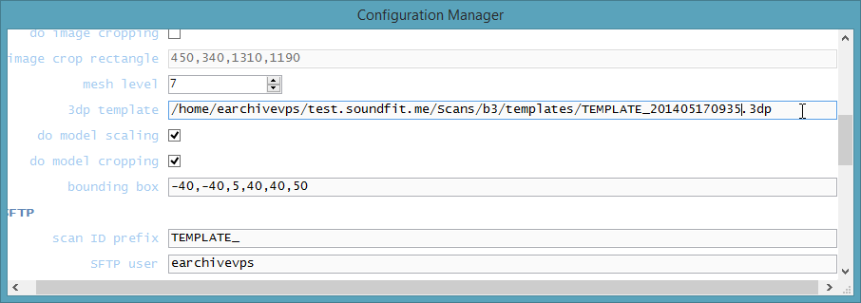

## Scan test object

Ensure an object with known dimensions is inside the SugarCube.

Run SugarCube Tester. Then click ***Run Shoot String***.



After the scan is complete click the Upload Scan button to up load the image-set.

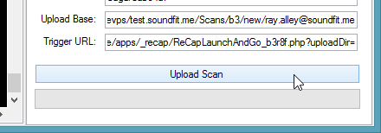

An email will notify you when your files are ready.

## Validate scale

Open the STL file with a 3D viewer that can measure dimensions. Measure the object to determine if we were successful. Doing so for this example led to the following result.



If the scale was off by more than 100 microns recalculate the scale factor and update the template. I had to perform this step 1 out of 5 times. The table below represents the results. I took a second sample since 1 out of 10 models have scaling issues, however it match.



The correction for the above offset was 0.9937 resulting in the following.



# Appendix

## Null template

The image below is a clip of the Null template, which is also in the template folder under the “b3” fork on the server. The file name is “template_140508-1143_UNSCALED.3dp”. For those of you aware of the 3dp file you may notice that all positional information has been removed forcing the modeling program to find them.

**WARNING every specific shooting string requires a custom template**.

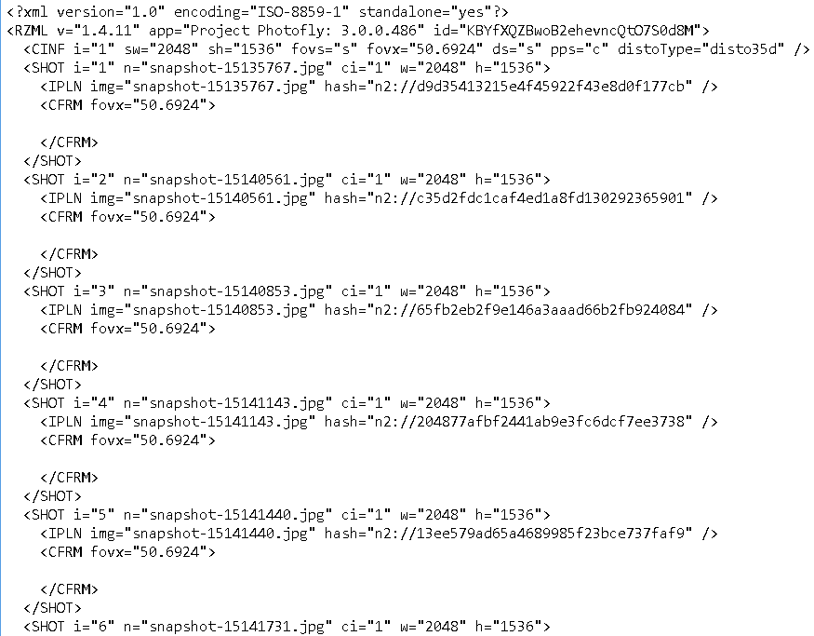

## Deficiencies

The list below identifies deficiencies that need to be addressed.

* 2 digit display needs to be replaced with 4 digit display to match requirements
* Access to templates with SugarCube Tester
* Incorporate extract application into SoundFit application
* A table to place measurements and calculate scale could be useful
* Add a section for setting up the cropping boundaries